CROP PROTECTION USING INTELLIGENCE SURVEILLANCE SYSTEM

A project report submitted to
Jawaharlal Nehru Technological University Kakinada, in the partial
Fulfillment for the Award of Degree of

BACHELOR OF TECHNOLOGY
IN
COMPUTER SCIENCE ENGINEERING

Submitted by
PURIMITLA GOWTHAMI PRIYA 21491A44A0
PABOLU PAVITHRA 21491A4462
NUNNA BHARGAVI NAIDU 21491A4499
SHAIK ADIL 21491A44C1
SHAIK SADIYA 21491A44C6
BOYALLA MANJULA 21491A44C7
BODIGIRI SILPA 21491A44C9

Under the esteemed guidance of
Dr. JYOTHI PULAKANTI
Associate Professor

DEPARTMENT OF COMPUTER SCIENCE ENGINEERING
QIS COLLEGE OF ENGINEERING AND TECHNOLOGY
(AUTONOMOUS)
An ISO 9001:2015 Certified institution, approved by AICTE & Reaccredited by NBA, NAAC ‘A+’ Grade
(Affiliated to Jawaharlal Nehru Technological University, Kakinada)
VENGAMUKKAPALEM, ONGOLE – 523 272, A.P
November, 2024

QIS COLLEGE OF ENGINEERING AND TECHNOLOGY
(AUTONOMOUS)
An ISO 9001:2015 Certified institution, approved by AICTE & Reaccredited by NBA, NAAC ‘A+’ Grade (Affiliated to Jawaharlal Nehru Technological University, Kakinada)
VENGAMUKKAPALEM, ONGOLE: -523272, A.P
November 2024
DEPARTMENT OF COMPUTER SCIENCE ENGINEERING
CERTIFICATE
This is to certify that the technical report entitled “Crop Protection Using IntelligenceSurveillance System”is a bonafide work of the following final B Tech students in the partial fulfillment of the requirement for the award of the degree of bachelor of technology in COMPUTER SCIENCE ENGINEERING for the academic year 2024-2025.

PURIMITLA GOWTHAMI PRIYA 21491A44A0
PABOLU PAVITHRA 21491A4462
NUNNA BHARGAVI NAIDU 21491A4499
SHAIK ADIL 21491A44C1
SHAIK SADIYA 21491A44C6
BOYALLA MANJULA 21491A44C7
BODIGIRI SILPA 21491A44C9
Signature of the guide Signature of Head of Department
Dr.., M.Tech, Ph.D Dr. M.Tech, Ph.D
Associate Professor HOD, Professor in ME

Signature of External Examiner

ACKNOWLEDGEMENT

Submitted by
PURIMITLA GOWTHAMI PRIYA 21491A44A0
PABOLU PAVITHRA 21491A4462
NUNNA BHARGAVI NAIDU 21491A4499
SHAIK ADIL 21491A44C1
SHAIK SADIYA 21491A44C6
BOYALLA MANJULA 21491A44C7
BODIGIRI SILPA 21491A44C9

ABSTRACT
This project targets crop damage caused by wildlife, such as pigs and elephants, which are being forced into farmlands as human activity increases. Scarecrows and electric fences are common but useless deterrents. The proposed approach uses ultrasonic waves, LED lights, and smartphone alerts to provide automatic animal detection, identification, and repelling, providing excellent crop protection while causing minimal animal injury.[18]Wild Animal Detection and Protection of PIR (Passive Infrared) Sensor Detects animal movement on the farm.Buzzer Alarm can activate when animal motion is detected, scaring away intruders.
[24] Alert Mechanism for Quick Action If the animal persists in the field despite the warning, the system sends continual alerts to the farmer, allowing prompt intervention to prevent crop loss. Protecting Wildlife Unlike electric fences and other destructive approaches, our solution is non-invasive and environmentally beneficial, deterring animals with sound alerts rather than physical injury. Ensure 24-hour monitoring. Farmers cannot always be physically present on their crops. [30] The technology provides ongoing monitoring and notifications, allowing them to concentrate on other agricultural fields. Farmers receive real-time SMS alerts when an animal is detected and identified. Electric fences are susceptible to harm from large animals and ineffectual against smaller animals. Image recognition systems are limited in processing capacity and ambient circumstances. [12] This technology not only protects crops against animal intrusion, but it also ensures the long-term and safe management of animals, balancing environmental concerns with farmers' livelihoods. The research aims to create an animal recognition and repelling system that employs modern sensors and acoustic processing.[6]

Keywords: ESP32 Camera, Ultrasonic Sensor, GSM Module, PIR Sensor, IoT, Animal Detection.

TABLE OF CONTENTS
CHAPTER NO. | TITLE |  |  |  | PAGE NO.
i | ABSTRACT |  |  |  | i
 | LIST OF TABLES |  |  |  | ii
 | LIST OF FIGURES |  |  |  | iii
 | LIST OF SYMBOLS AND ABBREVIATIONS |  |  |  | iv
1 | INTRODUCTION |  |  |  | 1
2 | Literature Survey |  |  |  | 2-3
3 | Materials and Methods |  |  |  | 4-10
4  5  6 | Results and Discussion  Conclusion 11  Future Scope 12 |  |  |  | 10-11
7 | References |  |  |  | 12-15

LIST OF FIGURES
FIGURE NO. | TITLE | PAGE  NO.
1 | Traditional Methods of Crop Protection From Wild Animals | 1
2 | Automated Crop Protection System | 2
3 | Raspberry Pi | 4
4 | ESP 32 CAM Module | 5
5 | Breadboard | 6
6 | Animal Classification using CNN (Convolutional Neural Network) | 6
7 | GSM Module | 7
8 | PIR Sensor | 8
9 | Face Detection using Haar Cascade | 9
10 | HAAR feature according to Viola-Jonas's algorithm | 10
11 | Smart Protection using AI | 12

LIST OF SYMBOLS AND ABBREVIATIONS
S.NO TITLE PAGENO 1 CNN - Convolutional Neural Network 1 2 FOTA - Firmware Over-The-Air 7
1. Introduction
Agriculture is still central to global food security and livelihoods, particularly in rural areas. A critical challenge to overcome is defending crops from animal invasions that can be devastating, resulting in enormous losses for farmers. Traditional approaches, like manual watch or heavy material barriers are not enough to immediately react. Over the years, more sophisticated CP surveillance systems have been proposed and developed such as integrating Internet of Things (IoT) or artificial intelligence (AI) applications that can automatically classify captured images. It is important to provide the crop system with such technologies that allow continuous monitoring and be subjected to immediate intervention, as animals are a continuing threat.
The increasing demand for more dependable and effective ways to stop animal invasions without necessitating continual human intervention is what inspired this idea. Farmers may be outfitted with sophisticated devices that not only keep an eye on their fields but also identify and respond to dangers instantly by utilizing the potential of IoT and AI. The invention of this system was primarily motivated by the potential to increase crop security and decrease losses brought on by animal activity. It provides an automated and economical solution to one of agriculture's persistent issues.
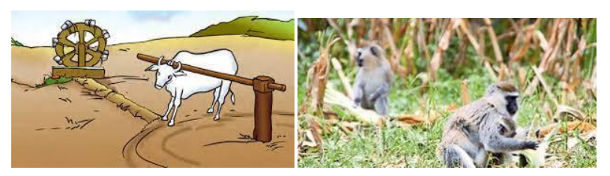
Fig : Traditional Methods of Crop Protection From Wild Animals
Animal incursions into agricultural fields continue to be a serious issue that reduces crop yields in spite of current controls. Farmers frequently lack the capacity to identify these invasions in a timely manner, which causes remedies to be delayed and crop damage to grow. Existing techniques are either static or unable to distinguish between distinct dangers, such as identifying particular animal species or differentiating between the presence of humans and animals. An intelligent system that can precisely identify, categorize, and discourage animals while alerting the farmer in real time is therefore desperately needed.
In order to monitor fields and stop animal interference, this project aims to develop an intelligent surveillance system that combines IoT and AI technologies. A motion-detecting PIR sensor activates an ESP32-CAM module in the system, which takes real-time pictures. Machine learning methods are then used to evaluate these photos. For example, a Convolutional Neural Network (CNN) is used to classify the animal species, and Haar feature-based classifiers are used to determine whether the creature is human or animal. To discourage the animal, an ISD1820 Voice-Sound Recording-Playback Module plays species-specific noises in reaction to the detected threat. The farmer can react to the problem since the system simultaneously notifies them using a GSM module.

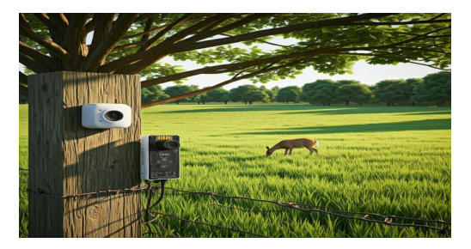 Fig : Automated Crop Protection System
The goal of this project is to offer a complete, completely automated crop protection system that uses AI and IoT to enable real-time monitoring and response. The system's integration of cloud storage for remote access and data processing makes it scalable and flexible enough to be used in a variety of agricultural settings. Small to medium-sized farms can use it since it is economical and successful, and it has the potential to be developed for more extensive agricultural and wildlife control uses. Farmers will be much better equipped to safeguard their crops thanks to this creative method, which will ultimately increase agricultural sustainability and output.

2. Literature Review / Background
The paper "Edge AI in Sustainable Farming: Deep Learning-Driven IoT Framework to Safeguard Crops from Wildlife Threats" presents a system that combines Tiny ML-based deep learning with IoT [1]. The system uses Evo Net, a lightweight deep learning model with 96.7% accuracy for animal classification, and AI-CAM devices and a laser detection mechanism to monitor and deter animals. It aims to reduce crop damage and promote sustainable farming [7]. The AI-based Scarecrow Prevention (YOLOv3) uses an object detection algorithm to identify animals. Once detected, sounds are triggered to scare animals away, offering a safer alternative to traditional methods [13]. IoT-based Smart Crop Protection and Irrigation monitors and manages crop protection and irrigation using sensors to collect data on soil moisture, weather, and pests. The Animal Intrusion Surveillance System (YOLO) automates crop protection using YOLO image processing to detect and identify animals from camera feeds [19]. The article emphasizes new research opportunities in applying Industry 4.0 principles to agriculture [25]. This deep dive is an examination of the application of Convolutional Neural Networks (CNN) for the animal sector, such as image classification, object detection, segmentation, pose estimation, and tracking [3]. An IoT-based crop protection system is based on the use of PIR and ultrasonic sensors which can detect the movement of animals and alerting farmers via GSM [9]. A system with the use of Edge5 AI and TinyML within IoT for animals' intrusion detection and classification finds high-performance (96.7%) and is intended to be both prevention of large agricultural areas while also promoting ecology conservation[15]. Animal detection with R-CNN models is compared by means of deformable convolutional layers to increase accuracy and speed [21]. The digital transformation in the rural areas that is being pursued enables farmers to implement the digital tools for an agriculture that is smarter and more efficient [27]. The crop protection system based on the Arduino platform are automated using motion detection and PIR sensors, which helps in protecting crops from animals. This system ensures achieving both social and economic gains for the farmers [6]. The IoT-based system consists of the esp8266 (Node MCU) sensors and GSM modules, which are used for the monitoring and alarming of any animal movements and entry to the crop area [12]. The system also provides real-time monitoring through cameras and automated crop protection [18]. The Agriculture Crops Protection System, developed and implemented with the Arduino platform, PIR sensors, and a GSM module helps in the detection of intrusion, where in turn an; audible buzzer and sending an SMS to the farmers are the main actions that the system executes [24]. The IoT-based system is designed to safeguard the crops from large animals such as elephants and wild pigs, which it does using ultrasonic sensors and GSM modules for continuous sensing and instant action. The animal recognition system, which is powered by a Raspberry Pi 4, along with the sensors PIR, sound and SOPARE recognition, can identify and repel animals with specific ultrasonic frequencies [30]. This research explores the use of image processing and IoT for animal detection and repelling on farmlands. The system uses laser sensors and acoustic signals to deter animals without harm, promoting humane methods and reducing conflicts [4]. The system also incorporates AI for animal recognition and automated responses, offering an efficient solution for crop protection. The system uses laser sensors, motion detectors, and acoustic signals to safely repel animals from agricultural areas [10]. It identifies specific animals and triggers species-specific deterrents, demonstrating the potential for scalable, non-lethal methods in protecting crops from wildlife. YoLOv5 algorithm for real-time animal detection using precision agriculture tools [16]. The intelligent secure smart crop protection from wild animals uses IoT, PIR sensors, and Pi cameras to detect and notify farmers of animal intrusions in real-time [22]. The prototype for smart crop protection against wild animals uses Arduino microcontrollers, motion sensors, and OpenCV software to detect animal movements and send real-time alerts to farmers [28]. This method basically alerts the farmers if there are any unauthorized intrusions by animals through SMS/calls, and additionally, they can safeguard crops by using GSM technology[5]. This method is highly effective and inexpensive because it uses an Arduino system that is capable to do animal monitoring and sending signals in real-time[11]. For instance, the PIR sensors have been leveraged to detect animals. Besides, intersects come load cells and an Arduino to detect animals and sound deterrence at different frequencies. The fourth method would be full of relevance as it would be able to measure the techniques of damage estimation more accurately and quickly [17]. The latter method amplifies the problem of wildlife; however, it is better in terms of the requirement of labour and accuracy which makes it the best selection for farmers who are struggling to keep away wildlife while increasing the crop output [23]. The method seeks to alert a constant animal checkup, every now and then, of the use of detection, classification, and deterrence to technologies like thermal imaging, unmanned vehicles, and photogrammetry [29]. The Smart Agricultural Security System (ICSES 2023) uses Arduino technology to detect intruders and monitor crop conditions, integrating soil monitoring sensors for optimal plant growth [2]. Non-harmful repellents are deployed to prevent crop vandalism by wild animals, reducing human-animal conflicts while maintaining crop security [8]. The Smart Intrusion Detection Using Arduino (ICIRCA 2020) uses PIR and ultrasonic sensors, a camera, and GSM module for reporting threats[14]. The Human-Animal Conflict Mitigation Using Embedded Systems and CNN integrates CNN for animal detection via image segmentation [20]. The Drone-Assisted Farm Protection System uses drone technology combined with IoT, Raspberry Pi, GPS, and GSM modules for real-time monitoring. These systems emphasize the use of IoT, AI, machine learning for non-harmful solutions for safeguarding crops from wildlife intrusion [26].

3. Materials and Methods
Raspberry Pi: It can be expressed as a small and cheap PC which is designed for educational needs and the development of DIY projects.
- *Processor*: In most cases, the Arm processor is multicore.
- *Memory*: Some models have 1 GB RAM while most have 2 GB to 8 GB RAM.
- *Storage*: Micro SD slot is used for the OS and file system.
- *Ports*: Several USB ports, HDMI output, audio jack, and Ethernet/Wi-Fi are available on the device.
- *GPIO Pins*: These are general-purpose input/output pins used to interconnect hardware devices such as sensors and motors.
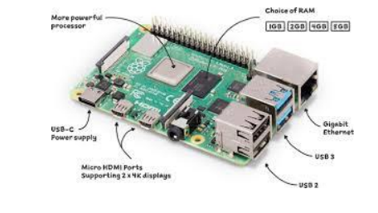
Fig. Raspberry Pi
BREAD BOARD: A breadboard is an electromechanical device that allows for the repeated construction of circuits, which have been tested and have succeeded in their primary purpose. In its construction it contains a grid of holes, additionally joined together via metal strips. This construction allows for the installation of circuit elements such as resistors, capacitors, and integrated circuits in a form that does not have to be soldered. That allows designing, testing, and changing circuits to be convenient and time-efficient. Usually, breadboards have power rails located at the ends of the breadboards making power supply connections more convenient.
ESP32-CAM:It is an ESP32-S powered microcontroller where a camera is embedded with the board as well as a microSD card holder.This is ideal for IoT projects that need a more advanced camera module.
Specifications:
DHCP WiFi 802.11b/g/n, Bluetooth 4.2 with BLE
UART, SPI, I2C, PWM
Up to 160 MHz clock, up to 600 DMIPS performance 520 KB SRAM + 4 MB PSRAM
Image upload through WiFi and many sleep states available
Camera:
Has an inbuilt OV2640 camera module (2 megapixels).
Can use camera Modules OV7670.
LED flashlight on board.
Antenna internal and external.
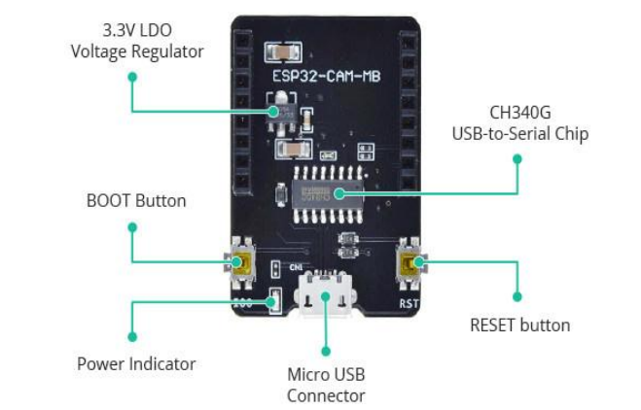
Fig. ESP 32 CAM Module
Breadboard: A breadboard is an electromechanical device that allows for the repeated construction of circuits, which have been tested and have succeeded in their primary purpose. In its construction it contains a grid of holes, additionally joined together via metal strips. This construction allows for the installation of circuit elements such as resistors, capacitors, and integrated circuits in a form that does not have to be soldered. That allows designing, testing, and changing circuits to be convenient and time-efficient. Usually, breadboards have power rails located at the ends of the breadboards making power supply connections more convenient.
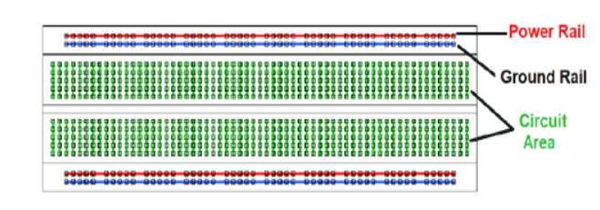
Fig. Breadboard
CNN ALGORITHM: A CNN algorithm in crop protection uses an intelligence surveillance system to capture images of crops and analyse them using a Convolutional Neural Network (CNN). This allows for early detection of potential threats like pests, diseases, or animal damage, enabling targeted intervention to protect crop yield. The CNN learns specific visual patterns from a large training dataset, enabling real-time monitoring and alerts to farmers. Benefits of using CNN include early detection, precision farming, and improved crop yields. Challenges include data requirements, lighting and weather conditions, and computational power.
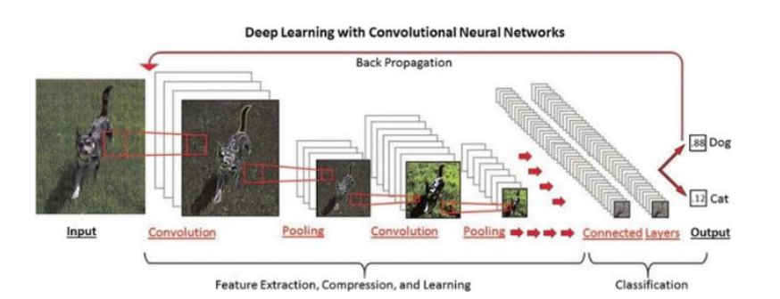
Fig: Animal Classification using CNN (Convolutional Neural Network)
GSM MODULE: A GSM module (also known as a GPRS module) enables a computer or mobile device to communicate with the GMS or GPRS system. It contains a modem (modulator de-modulator) and interface for communication. A GSM module (or GPRS module) establishes communication between a mobile device or computer and the GSM or GPRS system. It includes a modem (modulator-demodulator) and communication interfaces. GSM modules are in the form of external devices or inserted within devices. GSM mobiles are standalone systems with built in microprocessors for user-mobile network interfacing. Interfaces Bluetooth with Wi-Fi, BLE, UART, SPI, I2C, PWM. Up to 160 MHz of clock frequency and up to 600 DMIPS of computing capacity. Images can be uploaded through Wi-Fi. Multiple sleeping states and supporting firmware over-the-air (FOTA) upgrade.
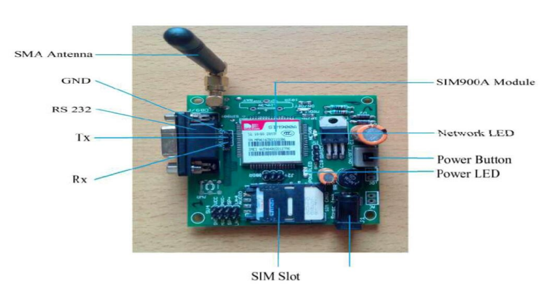
Fig: GSM Module
PIR Sensor (Passive Infrared Sensor): A PIR sensor is designed to detect changes in infrared (IR) radiation levels caused by the movement of warm objects, such as humans or animals.It gets frequent use in security alarms, automatic lighting applications, and other times when you want to detect the presence or a person (or pet) or some other object.PIR sensors detect motion by sensing changes in infrared (radiant heat) levels emitted by surrounding objects. The sensor has two halves, each sensitive to IR.
When a warm body passes across the sensor, one half of it becomes more IR dense then the other causing a positive differential change. Positive differential changes are generated when the body arrives; negative differential changes are generated when the body leaves. These changes pulses are recognized and employed to serve as an impetus for action (e.g., turning on lights or an alarm).

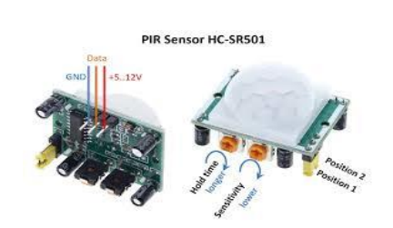
Fig: PIR Sensor
Components:
The sensor is contained in a metal can to provide immunity to noise and temperature.
It has a window made of IR-transmissive material.
Inside, there are balanced sensors and a low-noise JFET transistor.
Lenses:
PIR sensors use special type of lenses known as Fresnel lenses which are used to compress the infrared light which leads to increasing the overall detection zone.
These lenses can be described as the lens used in cameras, that focuses one large area to a small one.
Security systems, automatic lighting, occupancy detection, and energy-saving devices.
HAAR Feature:

Haar classifiers can be used to determine whether harmful bugs are flying onto plants, reducing food shortages caused by pests. Haar features are sequence of rescaled square shape functions proposed by Alfred Haar in 1909. They are similar to convolution kernels taught in the Convolution Neural Networks course. We will apply these Haar features to all relevant parts of face so as to detect human face.

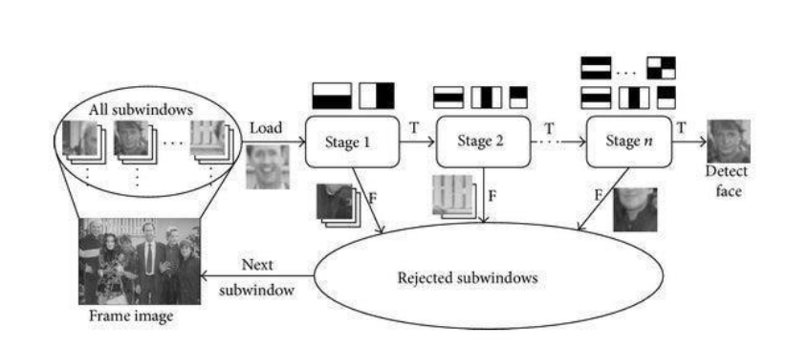
Fig:Face Detection using Haar Cascade

Example of Haar Features: Square shaped kernels.
As we see in the above image, there are edge features (1 and 2), line features (3). They are white and black pixels images (value 0 or value 1). But usually we have greyscale/colour image (pixel value range from 0 to 255). For now, assume ideal scenario that we have black and white image.

To detect eyebrow, we will use Haar feature (image (1)) because forehead and eyebrow form lighter pixels- darker pixel like image. Similarly, to detect lips we use similar to Haar like feature (image (3)) with lighter-darker-lighter pixels. To detect nose, we might use darker-lighter Harr like feature from (image (1)). And so on.
Let's look at some computations that are required.
For black and white image (refer first box below), pixel values are 0 or 1 (ideal case) but in real cases we have normalised greyscale image as shown in bottom box containing pixel values.
Pixel values: 0 and 1 for ideal case, Normalised greyscale values for real cases
According to Viola-Jonas's algorithm, to detect Haar like feature present in an image, below formula should give result closer to 1. The closer the value is to 1, the greater the change of detecting Haar feature in image.
Ideal case: Delta = (1/8) *(8) — (1/8) *0 = 1
Real case: Delta = (1/8) *(5.9) — (1/8) *(1.3) =0.575
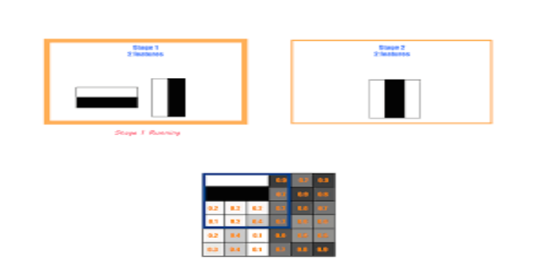
Fig: HAAR feature according to Viola-Jonas's algorithm

4. Results and Discussion

As the results that are been expected by the outcome of this project have a very good efficient and accurate. So firstly when the PIR sensors has detected then the ESP-32 cam module will be taken those pictures where the motion has been detected, if the data that is been small then the ESP-32 cam module can be capable of storing the data in it or else if the data is larger then the data will be stored in a cloud server. Thus after data has been collected then the HAAR feature comes in to the picture it will classify the data whether it is a Human or Animal.
According to Viola-Jonas algorithm, to detect Haar like feature present in an image, below formula should give result closer to 1.
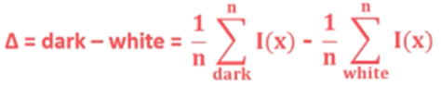
By the values that are 1 or closer than 1, the greater the change of detecting Haar Feature in image.
And after classifying it will give result as a Human or Animal. If it is human then by using the GSM module it will sends SMS to the farmer mobile as “HUMAN ENTERED IN THE FIELD”.
Otherwise, if it detects an Animal then CNN algorithm comes into the picture. It is one of the specialized types of deep learning algorithm that is mainly used for object detection, image classification. As by having convolutional layers they will be able to apply filters to input data by capturing local patterns and features. Such that if the entered Animal is a Domestic Animal then by the help of sound speakers it will be able to produce some disturbing sounds as well as at same time by GSM module an SMS is going to send to farmer mobile as “DOMESTIC ANIMAL ENTERED IN THE FIELD”.
If the entered animal is Wild Animal, then the GSM module sends an SMS to farmer mobile as “WILD ANIMAL ENTERED IN THE FIELD”.

5. Conclusion
The challenge of animal incursions in agriculture remains a significant threat to crop yields and farmer livelihoods. Traditional methods are increasingly inadequate in providing timely and effective responses to this issue. This project proposes an innovative solution that harnesses the capabilities of IoT and AI to create a comprehensive, automated crop protection system.[2]
The literature review demonstrates a wide array of existing technologies aimed at addressing this problem, including various sensor integrations and machine learning algorithms. However, many of these systems still suffer from limitations in terms of real-time response, species.[8]
Differentiation, and user accessibility. Our proposed system aims to fill these gaps by offering a robust solution that combines motion detection, image classification, and immediate farmer notifications, thus enhancing the efficiency of crop protection measures.[14]
The integration of cloud-based data storage ensures scalability, allowing for adaptation across different agricultural contexts, particularly in small to medium-sized farms. By utilizing automated deterrents and real-time alerts, this system not only aims to mitigate losses due to animal invasions but also promotes sustainable agricultural practices through humane intervention methods.[20]
Ultimately, this project has the potential to transform how farmers protect their crops, increasing agricultural productivity while reducing the risks associated with wildlife conflicts. As technology continues to advance, such smart systems will play a crucial role in ensuring food security and supporting the livelihoods of farmers worldwide.[26]
6. Future Scope
There is a lot of promise for future developments in protecting agricultural fields from animal incursions with the suggested approach of utilizing IoT and AI for crop protection. More advanced functions, such the ability to predict animal behavior, may be added as the system develops. Future iterations of the technology might be able to predict animal movement patterns by utilizing larger datasets that are kept in the cloud. This would enable farmers to take preventative measures to stop possible damage before it happens. The system's capacity to monitor vast regions and react to threats faster may also be improved by using drone technology for broader and more dynamic field surveillance.

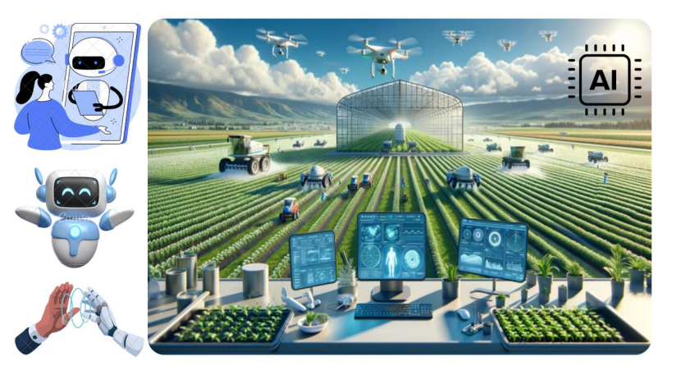
Fig : Smart Protection using AI

The system will be able to better customize its deterrent actions depending on the type of animal detected thanks to further advancements in AI algorithms, especially in deep learning, which will improve the accuracy of species recognition and behavioral analysis. By incorporating real-time learning, the system may be able to continuously modify its responses in light of prior exchanges, gradually increasing its efficacy.
The system's real-time capabilities will be improved by faster and more dependable data transfer between the field and the cloud thanks to developments in communication technologies like 5G. Farmers will receive notifications and reactions to possible risks more quickly as a result of the ability to intervene more quickly.
Crop protection will become more effective, dependable, and scalable in the future when a highly autonomous and intelligent surveillance system is developed that not only responds to incursions but also anticipates them. With clever, automated solutions, the strategy might completely change how farmers safeguard and maintain their fields, minimizing crop loss and boosting agricultural output.

References / Bibliography
[1] Reddy, K. V., Reddy, B. K., Goutham, V., Mahesh, M., Nisha, J. S., Gopinath, P., ... & Varsha, R. (2024). Edge AI in sustainable farming: Deep Learning-Driven IoT Framework to Safeguard Crops from Wildlife Threats. IEEE Access.
IoT Framework to Safeguard Crops from Wildlife Threats. IEEE Access.
[2] Aranganathan, A., Vedanarayanan, V., Sivasundarapandian, S., & Gomathi, T. (2023, December). Smart Agricultural Security System: Integrating Arduino Technology for Intruder Detection and Crop Protection. In 2023 International Conference on Innovative Computing, Intelligent Communication and Smart Electrical Systems (ICSES) (pp. 1-6). IEEE.
[3]. Li, G., Huang, Y., Chen, Z., Chesser Jr, G. D., Purswell, J. L., Linhoss, J., & Zhao, Y. (2021). Practices and applications of convolutional neural network-based computer vision systems in animal farming: A review. Sensors, 21(4), 1492.
[4] Baral, K., Sharma, H. P., Kunwar, R., Morley, C., Aryal, A., Rimal, B., & Ji, W. (2021). Human-wildlife conflict and impact on livelihood: A study in common forestry system in mid-hills of Nepal. Sustainability, 13, 1370

[5]. Lakshmi, K. M., Raja, C., Sreekanth, D., & Renuka, N. (2020). Security for protecting agricultural crops from wild animals using gsm technology. Journal of Shanghai Jiaotong University, 16(7), 1007-1172.
[6].Thirrunavukkarasu, R. R., Arunachalam, J., Manoj Kumar, P., Prasath, R., Meeradevi, T., & Ganesh Prabhu, S. (2021, March). Smart Irrigation And Crop Protection Using Arduino. In 2021 7th International Conference on Advanced Computing & Communication Systems (ICACCS) (pp. 1-6), IEEE.
[7] Harshini, M., Varshith, L., Rahul, K., Kothamasu, V. V. P., & Gnanadeep, Y.
(2023, October). Automatic Music Player Based on the Facial Expression. In 2023
International Conference on Self Sustainable Artificial Intelligence Systems (ICSSAS)
(pp. 917-920). IEEE.
[8] Sumathi, R., Raveena, P., Rakshana, P., Nigila, P., & Mahalakshmi, P. (2022, June). Real Time Protection of Farmlands from Animal Intrusion. In 2022 IEEE World Conference on Applied Intelligence and Computing (AIC) (pp. 859-863). IEEE.
[9]Deshmukh, M. N. V., Deshmukh, R. M., & Likhitkar, P. (2021). SMART CROP PROTECTION SYSTEM AGAINST WILD ANIMALS USING IOT.

[10] P.Navaneetha1, R.Ramiya Devi2, S.Vennila3, P.Manikandan4, Dr.S.Saravanan5, “Crop protection against Wild animals attacks”. Year 2020.
[11]. Gajanan, M. K. M., Suryakant, M. J. K., Suresh, M. A. S., & Shrikant, K. S. (2024). System for Protecting Crops from Animals. International Journal, 27(5), 35-40.
[12].Deotale, P., & Lokulwar, P. (2021, March). Smart Crop Protection System From Wild Animals Using IoT. In 2021 7th International Conference on Advanced Computing & Communication Systems (ICACCS) (pp. 1-2), IEEE.

[13] Nanda, I., Sahithi, C., Swath, M., Maloji, S., & Shukla, V. K. (2020, November).
IIOT based smart crop protection and irrigation system. In 2020 Seventh International
Conference on Information Technology Trends (ITT) (pp. 118-125). IEEE.
[14] Yadahalli, S., Parmar, A., & Deshpande, A. (2020, July). Smart intrusion detection system for crop protection by using Arduino. In 2020 Second International Conference on Inventive Research in Computing Applications (ICIRCA) (pp. 405-408). IEEE.
[15]K. V. Reddy et al., "Edge AI in Sustainable Farming: Deep Learning-Driven IoT Framework to Safeguard Crops From Wildlife Threats," in IEEE Access, vol. 12, pp. 77707-77723, 2024, doi: 10.1109/ACCESS.2024.3406585
[16] Sirisha, U., Sai Chandana, B. (2022). Semantic interdisciplinary evaluation of image captioning models. Cogent Engineering, 9(1): 2104333.
[17]. Deepa, S., Alagulakshmi, G., Illakkiavathy, R., Keerthana, M., & Preethi, K. S. (2021). Implementation of crop protection system against Wild Animals Attack. Annals of the Romanian Society for Cell Biology, 3638-3646.

[18].Manikandan, P., Thenmozhi, A., Ramesh, G., Ravi Kiran Naidu, T., Vamsinath Reddy, K., & BhanuPradeep Kumar Reddy, K. (2021, December). Crops Protection System from Animals using Arduino. In 2021 3rd International Conference on Advances in Computing, Communication Control and Networking (ICACCCN) (pp. 682-687), IEEE.

[19] Sathesh, A., Vishnu, K., Yuvaneshwar, A., Vellaisamy, V., & Gowthami, K.
(2022, March). Image Processing based Protection of Crops from wild animals usingIntelligent Surveillance. In 2022 International Conference on Electronics and
Renewable Systems (ICEARS) (pp. 1042-1046). IEEE.
[20] Kiruthika, S., Sakthi, P., Sanjay, K., Vikraman, N., Premkumar, T., Yoganantham, R., & Raja, M. (2023). Smart Agriculture Land Crop Protection Intrusion Detection Using Artificial Intelligence. In E3S Web of Conferences (Vol. 399, p. 04006). EDP Sciences.
[21].Ibraheam, M., Li, K. F., Gebali, F., & Sielecki, L. E. (2021). A performance comparison and enhancement of animal species detection in images with various R-CNN models. AI, 2(4), 552-577.
[22] S. K. L., A. Edison, Wild Animal Detection using Deep Learning, in 2022 IEEE 19th India Council International Conference (INDICON), Kochi, India, pp. 1-5 (2022).
[23]. Drimaj, J., Skoták, V., Kamler, J., Plhal, R., Adamec, Z., Mikulka, O., & Janata, P. (2023). Comparison of Methods for Estimating Damage by Wild Ungulates on Field Crops. Agriculture, 13(6), 1184.
[24]. Chitra, K., Tamilarasi, A., Pyingkodi, M., Nanthini, K., Sneka, V., Swetha, S., & Vishalini, P. (2023, January). Animals Detection System in the Farm Area Using IoT. In 2023 International Conference on Computer Communication and Informatics (ICCCI) (pp. 1-5), IEEE.
[25] Liu, Y., Ma, X., Shu, L., Hancke, G. P., & Abu-Mahfouz, A. M. (2020). From
industry 4.0 to agriculture 4.0: Current status, enabling technologies, and research
challenges. IEEE transactions on industrial informatics, 17(6), 4322-4334
[26] Kanimozhi, P., Kannan, M., Ananth, C., Kumar, T. A., & Parkavi, S. (2023, September). Design of IoT Based Agricultural Farm Protector Drone Using Raspberry Pi. In 2023 6th International Conference on Contemporary Computing and Informatics (IC3I) (Vol. 6, pp. 1175-1179). IEEE
[27]. Balaska, V., Adamidou, Z., Vryzas, Z., & Gasteratos, A. (2023). Sustainable crop protection via robotics and artificial intelligence solutions. Machines, 11(8), 774.
[28] Arduino UNO for beginners-Projects, Programming and Parts. Markerspaces.com. Retrived 4 Feburary 2018.
[29]. Sundaram, N., & Meena, S. D. (2023). Integrated animal monitoring system with animal detection and classification capabilities: a review on image modality, techniques, applications, and challenges. Artificial Intelligence Review, 56(Suppl 1), 1-51.
[30].Dissanayake, C. M., & Tennakoon, P. (2023, July). Sound Analysis-Based Animal Recognition and Repel System for Agriculture. In 2023 Moratuwa Engineering Research Conference (MERCon) (pp. 1-7), IEEE.

